# PARTITION BY Multiple Columns: Season and Month Analysis

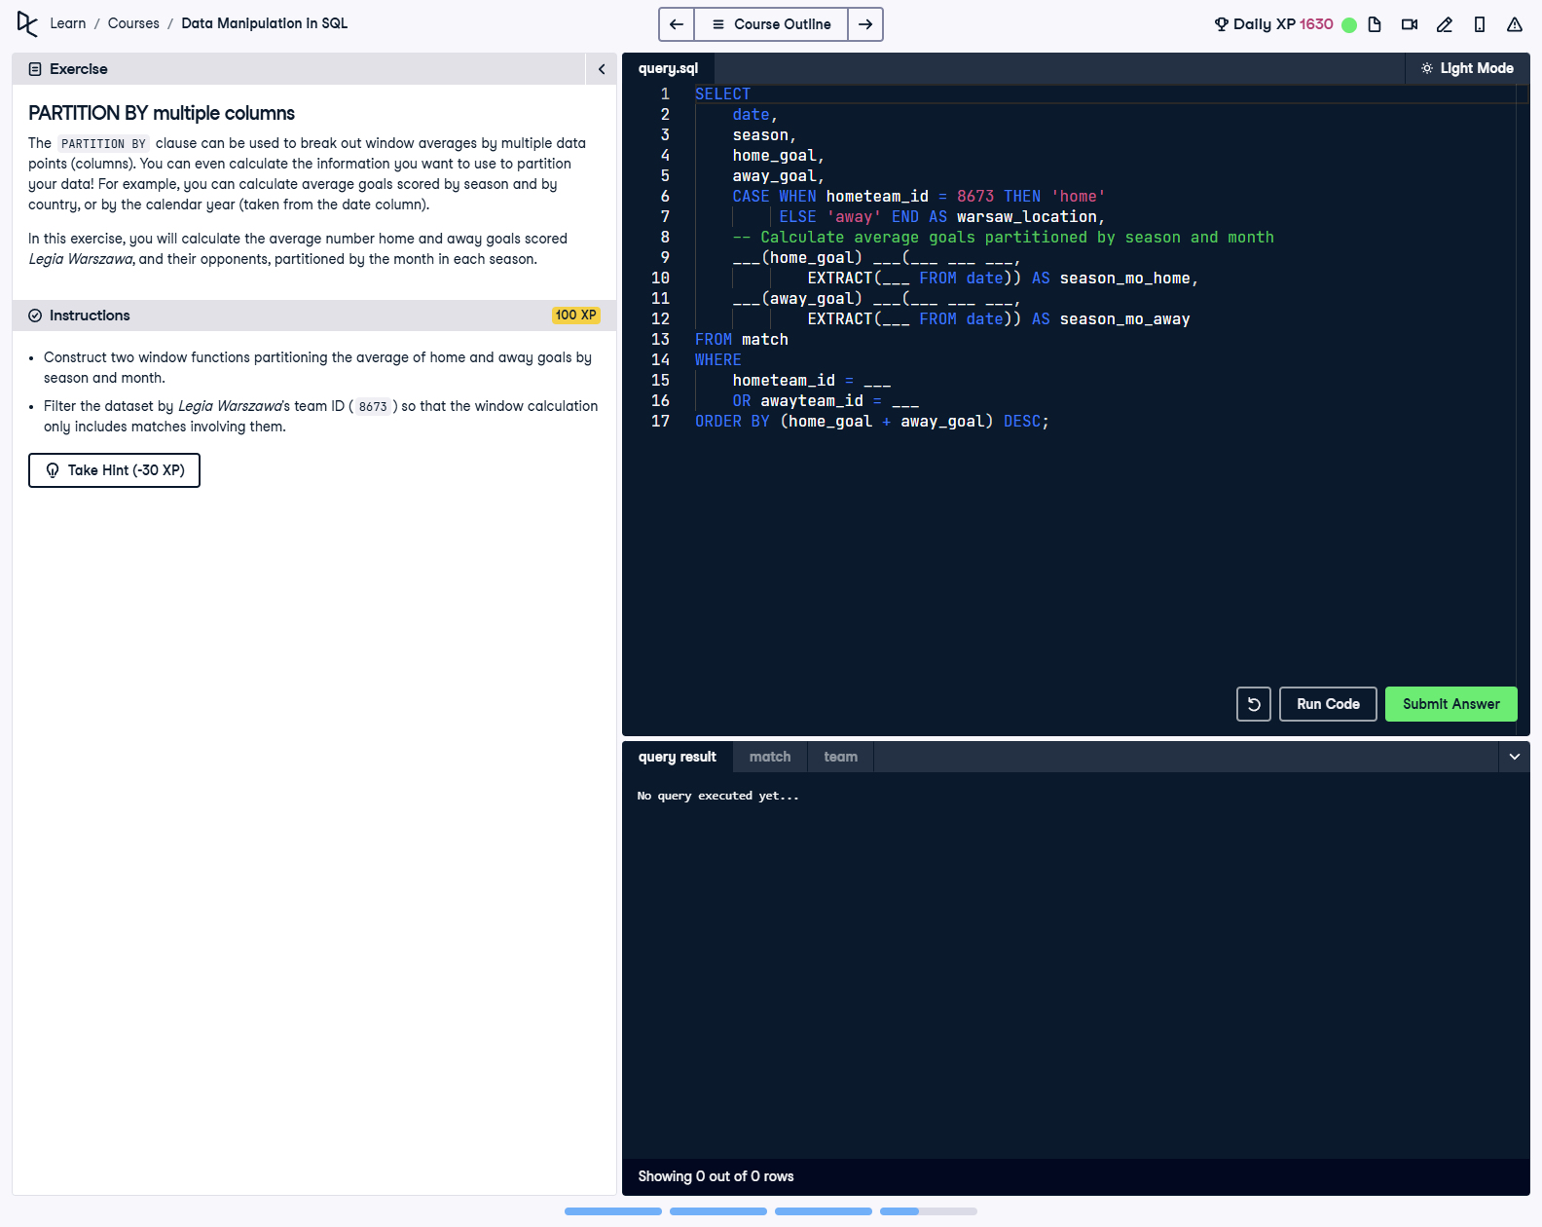

## Question

Using the PARTITION BY clause, calculate the average number of home and away goals scored by Legia Warszawa (team ID = 8673) and their opponents. Partition the averages by both season and month. Include match details, classify games as home or away, and order by total goals scored.

## Corrected Solution

SELECT  
 date,  
 season,  
 home_goal,  
 away_goal,  
 -- Determine if the match was home or away for Legia Warszawa  
 CASE WHEN hometeam_id = 8673 THEN 'home'  
 ELSE 'away' END AS warsaw_location,  
 -- Calculate average home goals partitioned by season and month  
 AVG(home_goal) OVER(PARTITION BY season, EXTRACT(MONTH FROM date)) AS season_mo_home,  
 -- Calculate average away goals partitioned by season and month  
 AVG(away_goal) OVER(PARTITION BY season, EXTRACT(MONTH FROM date)) AS season_mo_away  
FROM match  
-- Filter the data set for matches involving Legia Warszawa  
WHERE hometeam_id = 8673 OR awayteam_id = 8673  
-- Order the query by the total goals scored in descending order  
ORDER BY (home_goal + away_goal) DESC;

## Explanation

This query filters for matches involving Legia Warszawa and uses the PARTITION BY clause with season and month to calculate more granular averages for home and away goals. The CASE statement determines if the match was played at home or away, while the query sorts results by the total number of goals scored in each match in descending order. The inclusion of month in the partitioning provides finer details about seasonal performance.